

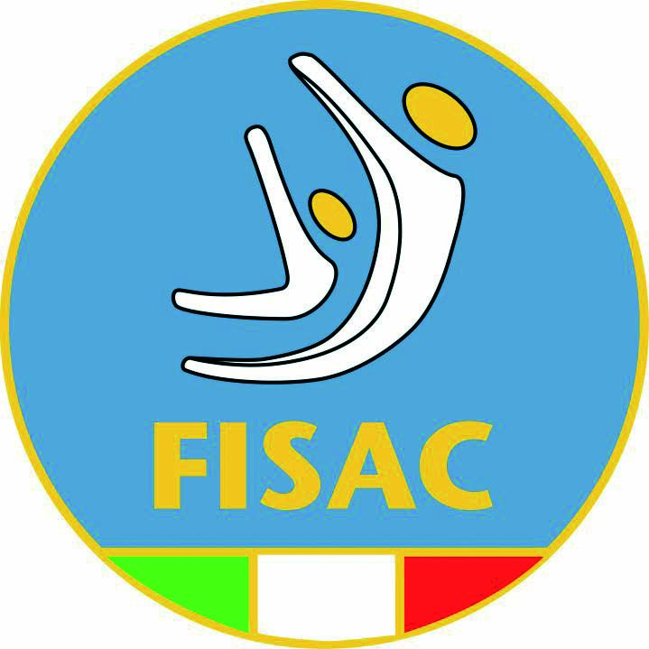

**INVITATION**

**1st CSIT AMATORIAL**

**GYMNASTICS CHAMPIONSHIP**

**June 8-12 , 2022 in Cesenatico / Italy**

**To:**

The CSIT, Member Unions, candidate unions and non-members of CSIT

The Chairman of the Gymnastic TC, Mr. Giampaolo Ciavolella

The Secretaries of the GymnasticTC

The Sports Director of CSIT: Mr. Henk Bouchoms, Mr. Georges Michel & Mr. Harold Van Hest

The General Secretary of CSIT: Mr. Wolfgang Burghardt

The President of the CSIT: Mr. Bruno Molea

Dear International Gymnastics Friends,

on behalf of Italian Federation of Acrobatic and Choreographic Sports (FISAC), we have the pleasure to invite you to the CSIT Gymnastic Championship in Cesenatico from 8 to 12 June 2022.

This Championship is open for Members and non Members of CSIT and will be organized in the spirit of brotherhood, respect and peace.

**ARTISTIC GYMNASTIC – FEMALE and MALE**

**RHYTHMIC GYMNASTIC**

**TEAMGYM**

**ROPE SKIPPING**

**ACROBATIC (Acrosport)**

**FITKID**

**CHOREOGRAPHIC GROUP GYMNASTIC**

**AERIALS**

**ACRODANCE**

**AEROBIC**

**PARKOUR**

**JUGGLING (only festival)**

FISAC is welcoming CSIT, its Amatorial Gymnastics Championship and the several thousands of participants from all over the world to practice different kind of gymnastics in the best atmosphere and conditions. It is an excellent opportunity for the CSIT family to meet and greet people from all over the world in a sportive way and we hope and we will work to maintain the CSIT traditions for this 1st Amatorial Gymnastics Champ.

**About the CSIT WORLD AMATORIAL GYMNASTICS CHAMPIONSHIPS**

The CSIT CHAMPIONSHIP is an open event for amateur and welcome member and (non-) member organisations, partners, governmental bodies, trade unions and companies from all over the word. The history of the CSIT World Games proves that this event has “Olympic allures”. It provides participants a real international sports week with touristic and cultural contents they will never forget!

**Invitation (more than 74 Countries from all the 5 Continents)**

It is a pleasure for FISAC to invite your teams and members to participate at the CSIT AMATORIAL GYMNASTICS CHAMPIONSHIPS. Cesenatico is going to be transformed into the CSIT Gymnastics Town, where the organisation of competitions is the foreground to promote friendship, the exchange of information and experiences within a sport frame. That’s the spirit of CSIT that will be the spirit of GYMNASTICS AMATORIAL GYMNASTICS CHAMPIONSHIPS 2022!

**FOR ANY INFORMATION REGARDING THIS INVITATION AND THE CHAMPIONSHIP PLEASE ASK TO** [**segreteria@fisacgym.it**](mailto:segreteria@fisacgym.it)

**STAY TUNED!**

You can always find news & information on the CSIT Gymnastics Championships Official Website (after 1st January 2022): [www.csitgymnasticschampionship.com](http://www.csitgymnasticschampionship.com)

Follow us also on Facebook (after 1st January 2022) : CSIT Gymnastics Championships

**We invite you to accept the following competitive offer:**

**CSIT Gymnastics Championships 2022: WHEN AND HOW TO GET HERE**

|  |  |
| --- | --- |
| **Date of arrival** | June 8-9 |
| **Date of departure** | June 12 |
| **Place of arrival** | |  | | --- | | Cesenatico, Italy | | (190 km from Venice, 150 km from Florence, 340 km from Rome) | |
| **International Airports** | * Bologna and Ancona * Rimini * Forlì |
| **Railway Stations** | * Cesena (15 km far from Cesenatico) |
|  | * Rimini (20 km far from Cesenatico) |
|  | * Cesenatico (800 m. far from Gyms Village) |
| **Transfer** | * Transfer from and to : * BOLOGNA or ANCONA Airport €. 50,00 each person (minimum 7 persons) * Transfer from and to Cesenatico railway station is for free. * Transfer from and to other destinations: ask |
| **Training days** | First day of each discipline |
| **Competition days** | See the list before |
| **Opening ceremony** | 8 June 2022 |
| **Closing ceremony** | 12 June 2022 |
| **Age categories** | See each Discipline technical regulation |
| **Composition of delegation (**it is permitted to attend with several teams per delegation**)** | * 1 Head of delegation * at least 1 coach * unlimited number of athletes (follow each Discipline technical regulation) |
| **Elegibility criteria** | Athletes could come from different International Federations ! Follow each Discipline technical regulation |
| **Technical Commission meeting** | 1 day before the start of competitions |
| **Registration fee** | Included in the packages |
| **PACKAGES GENERAL CONDITIONS** | **The package prices of category A & B** include:   * accommodation in full board service for 3, 4 or 6 DAYS (breakfast, lunch and dinner with free water per meal) * CSIT registration fee * welcome package * assistance on-site service throughout the event by the staff of the organizing committee * evening animations (where and when available). |
| **PACKAGE “A”** | **CSIT members (full, associate, candidate) and accompanying persons**  Accommodation in **Gym Village Accademia Acrobatica**:  STANDARD ROOM (no air condition and TV)  from 2 to 7 beds  **3 NIGHTS :**   * 180,00 Euro per person   **4 NIGHTS :**   * 210,00 Euro per person   **6 NIGHTS :**  - 285,00 Euro per person  Accommodation in **Gym Village Accademia Acrobatica**:  SUPERIOR ROOM (with air condition and TV) from 2 to 7 beds  **3 NIGHTS :**   * 205,00 Euro per person   **4 NIGHTS :**   * 240,00 Euro per person   **6 DAYS :**  - 330,00 Euro per person  Accommodation in **3 stars hotel**:  **3 NIGHTS**   * 270,00 Euro per person   **4 NIGHTS**   * 340,00 Euro per person   **6 NIGHTS :**  - 480,00 Euro per person  Accommodation in **4 stars hotel** and single rooms:   * ASK |
| **PACKAGE “B”** | **NO CSIT organizations: Sport Clubs, companies, externals, other organizations and accompanying persons**  Accommodation in **Gym Village Accademia Acrobatica**:  STANDARD ROOM (no air condition and TV) from 2 to 7 beds  **3 NIGHTS :**   * 215,00 Euro per person   **4 NIGHTS :**   * 250,00 Euro per person   **6 NIGHTS :**  - 325,00 Euro per person  Accommodation in **Gym Village Accademia Acrobatica**:  SUPERIOR ROOM (with air condition and TV) from 2 to 7 beds  **3 NIGHTS :**   * 240,00 Euro per person   **4 NIGHTS :**   * 280,00 Euro per person   **6 NIGHTS :**  - 370,00 Euro per person  Accommodation in **3 stars hotel**:  **3 NIGHTS :**   * 320,00 Euro per person   **4 NIGHTS :**   * 380,00 Euro per person   **6 NIGHTS :**  - 520,00 Euro per person  Accommodation in **4 stars hotel** and single rooms:   * ASK |
| **PACKAGE “C”** | **Participation only:**  Participants who do not use accommodation or transportation services included into the package category A or B, **pay 200,00 Euro as CSIT registration** **fee.** |
| **Competition places** | **Gym Village – See before** |

|  |  |  |
| --- | --- | --- |
|  |  |  |
| **Disciplines** | **Location** | **Period June** |
|  |  |  |
| **FITKID + AcroDance** | Oasi 2 | 8-12 |
| **Female Artistic** | Oasi 1 | 8-12 |
| **Rhythmic Gymnastic** |  |  |
| **Parkour** |  |  |
| **Ropeskipping** | Oasi 3 | 8-12 |
| **Acrobatic (acrosport)** | Oasi 1 | 8-12 |
| **Teamgym** |  |  |
| **Aerobic Gymnastic** |  |  |
| **Choreographic Group Gymnastic** | Oasi 2 | 8-12 |
| **Juggling** |  |  |
| **Aerials** |  |  |
| **Competition Secreteries** | Circus 2nd floor |  |
| **Volunteeres and Services** | Accademia meeting hall |  |
| **Judges Meeting** | Accademia meeting hall |  |
|  |  |  |

|  |  |
| --- | --- |
| **Preliminary entry** (4 months before the Championships) | **Saturday, 19th February 2022** Just indicate number of persons, gender, sports discipline, hotel categories, estimated day of arrival and departure |
| **Definitive entry** (2 months before the Championships) | **Saturday, 09th April 2022** Fill out names & e-mail accounts, gender, sports discipline, date of birth, accommodation categories, exact time of arrival / departure and travel details etc. (use special form) |
| **Correspondence** | Organizing Committee E-mail: [segreteria@fisacgym.it](mailto:segreteria@fisacgym.it)  Mr. Giampaolo Ciavolella (Chairman TC Gymnastics) E-mail: [giampaolo.ciavolella@fisacgym.it](mailto:giampaolo.ciavolella@fisacgym.it)  CSIT Sports Director E-mail: [sportsdirector@csit.tv](mailto:sportsdirector@csit.tv)  Office of CSIT E-mail: office@csit.tv |
| **Transmission registration form** | FISAC E-mail: [segreteria@fisacgym.it](mailto:segreteria@fisacgym.it) Address: V.le C.Colombo 35 – 47042 Cesenatico (FC) - Italia |

|  |
| --- |
| **All the PARTICIPANTS at first period can partecipate at opening ceremony - All the second period can partecipate at closing ceremony** |
| **All dates could be changed in relation to the number of subscribers !!** |
|

**Touristic tour and excursions**

All the participants will have the opportunity to visit the oldest world’s Republic, San Marino and the city of Ravenna, former capital of the Western Roman Empire at really cheeper costs with special guides!

More daily tours and excursions can be organized under request (for example, Venice, Florence, Rome, Verona)!

Dance, games and shows for all, everything fully free of charge!

Every day Cesenatico will be special because events and activities will be planned throughout the city. In the evening, after competition and enjoying walks through the city centre or Casa Italia.

Music and entertainment will be staged in different places in the city of Cesenatico, and through the accreditation the participant will be provided of a “afternoon and night life Animation Map” that can be followed step by step so that participants will not miss a single note!

The delegations from all over the world will enjoy the legendary nightlife, especially with popular discos and concerts.

**Payment procedure**

|  |  |
| --- | --- |
| **Payments** | Definitive Registration: Total payment (100%) until:  **09th April 2022** |
| **Delay** | ***Please take note that in case of delayed payments a penalty fee of 30%*** ***will be charged by the organizer according to the CSIT Articles.*** |
| **Bank** | Romagna Banca |
| **Account holder** | Accademia Acrobatica S.r.l. |
| **Reference** | *“CSIT Gymnastics Championships 2022”* |
| **IBAN** | IT89I0885224000001010007252 |
| **BIC / SWIFT code** | CCRTIT2TRMB |

**Cancellation policy**

* We must inform that FISAC will reserve the right of cancellation, if there are not at least 4 member unions preliminary registered at **09th April 2022**. In that case FISAC will refund **all** payments.

Based on the provisional registration of athletes it will be decided if the Gymnastics championships will be cancelled full or just some disciplines. This decision will be taken directly before the **09th April 2022**.

**Attention!**

1. *We advise you not**to book any flight tickets before this date (09th April 2022) and wait for a confirmation message from the host!*
2. *We advise you to proper insure your participants acc. to CSIT Sports Regulations! FISAC accepts no liability as a result of uninsured participants!*
3. *We ask your attention for respecting the deadlines in this invitation. Not respecting the deadlines will result in exclusion of your participation.*

In case of any questions don't hesitate to contact the Organizing Committee.  
  
Feel free to spread this invitation into your own sports network.

Looking forward to meet you in Cesenatico at the CSIT Gymnastics Championships!

Cordial greetings,

On behalf of the FISAC Organizing Committee

FISAC President

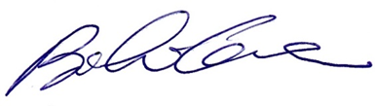Ing. Bianchi Cesare

